AI ASS 14.1
Name:S.Srija
H.T.N0:2303A52412
Batch:44

Task1:portfolio website Prompt:
Create a modern personal portfolio website using HTML, CSS, and JavaScript with About, Projects, and Contact sections, clean colors, typography, and a responsive Flexbox/Grid layout.
Add smooth scrolling navigation to enhance user experience with a simple and visually appealing design.
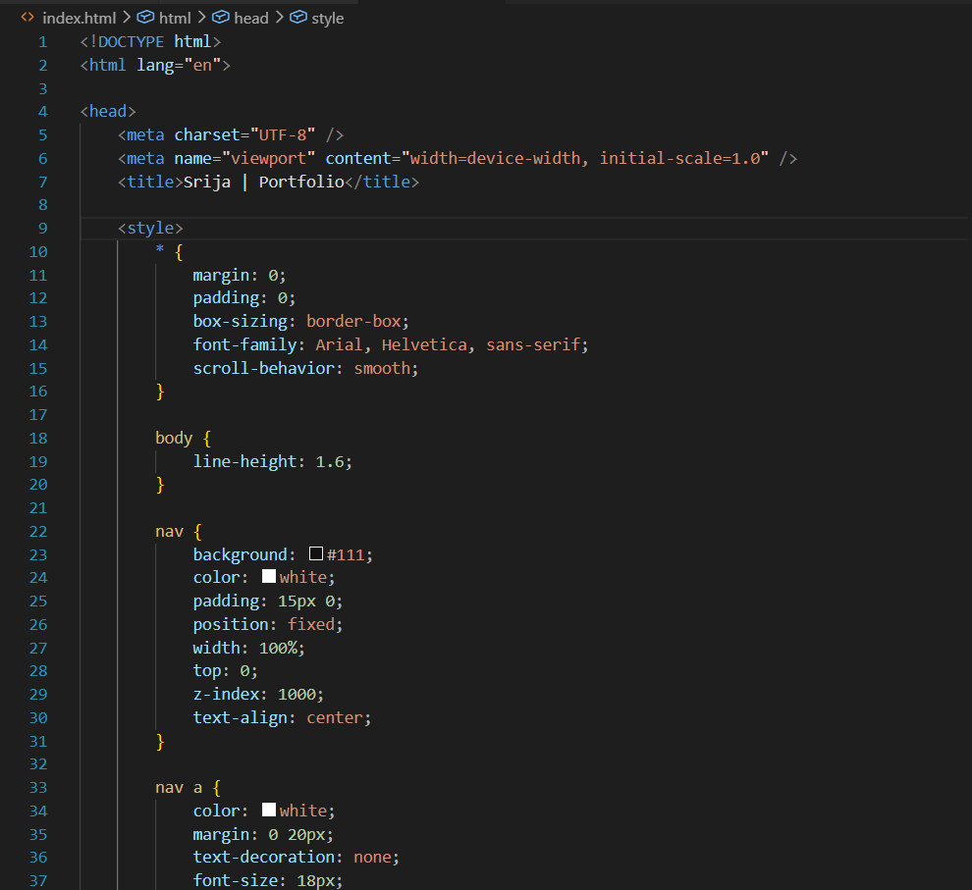

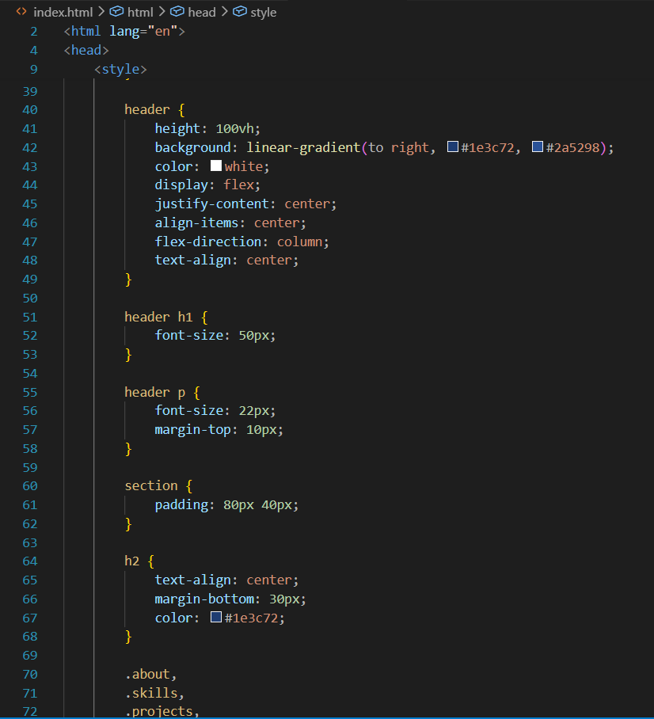

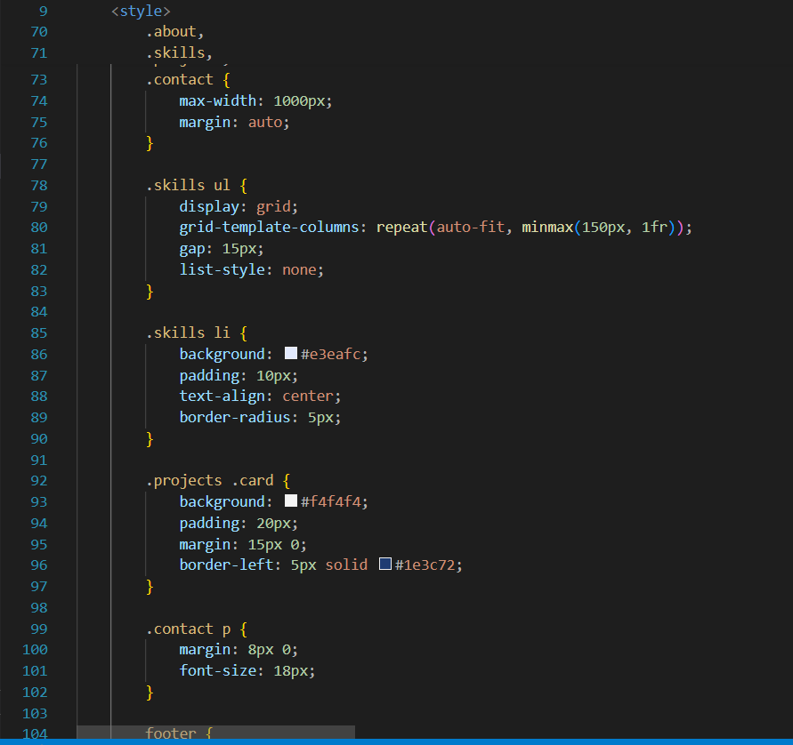

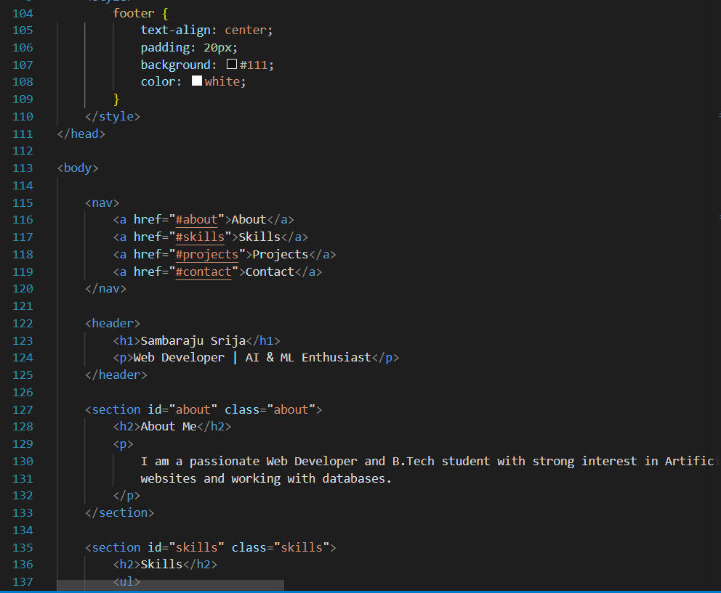

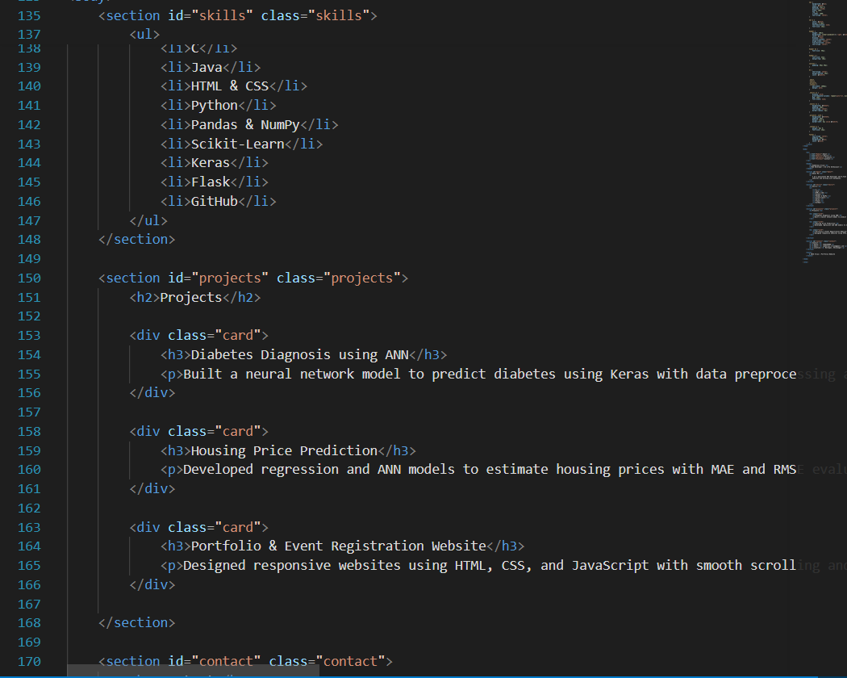

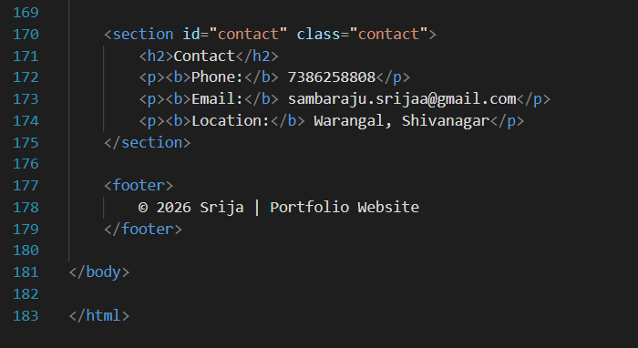

Output:

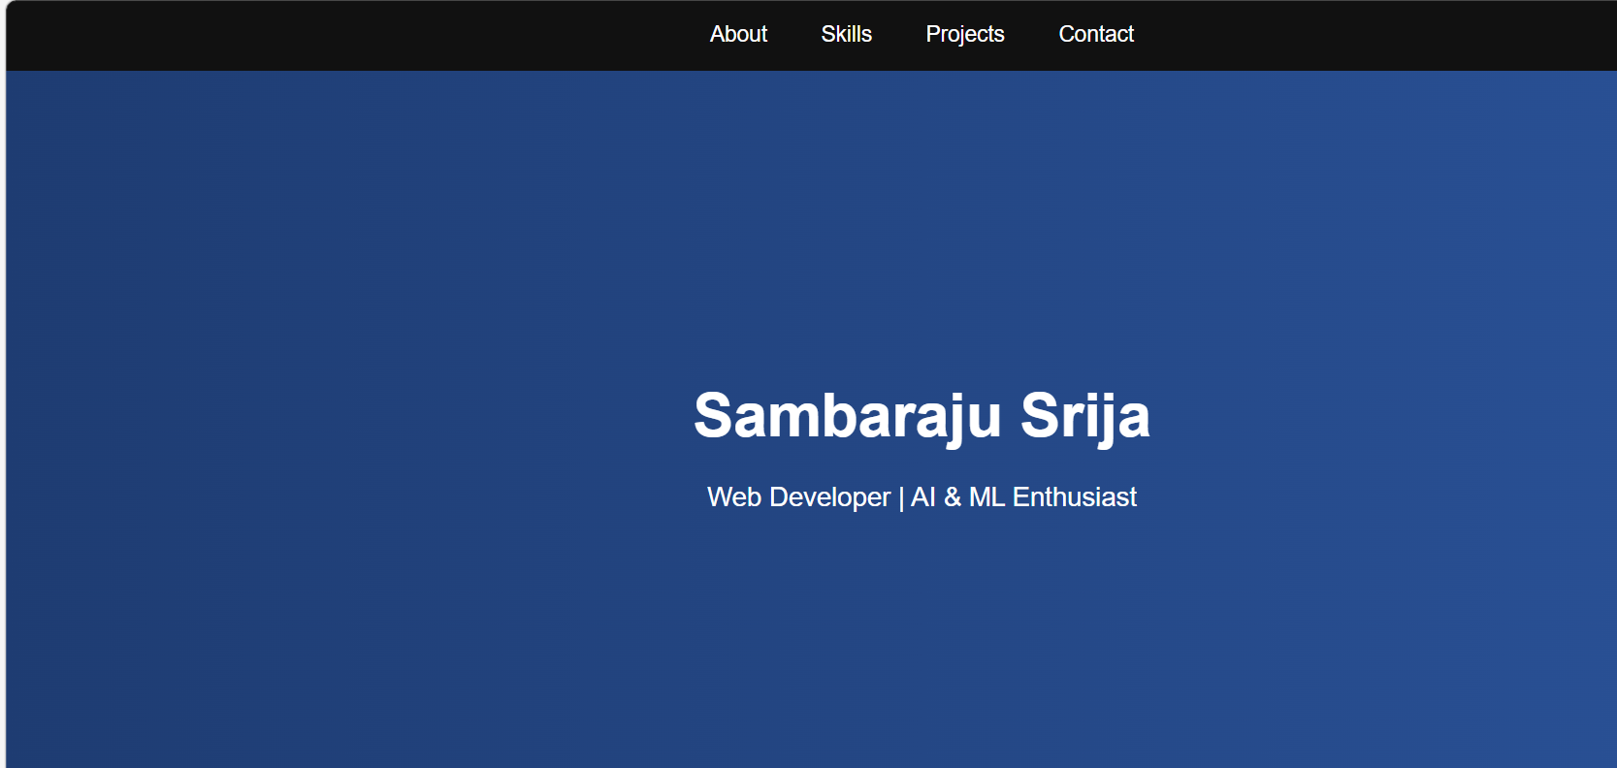

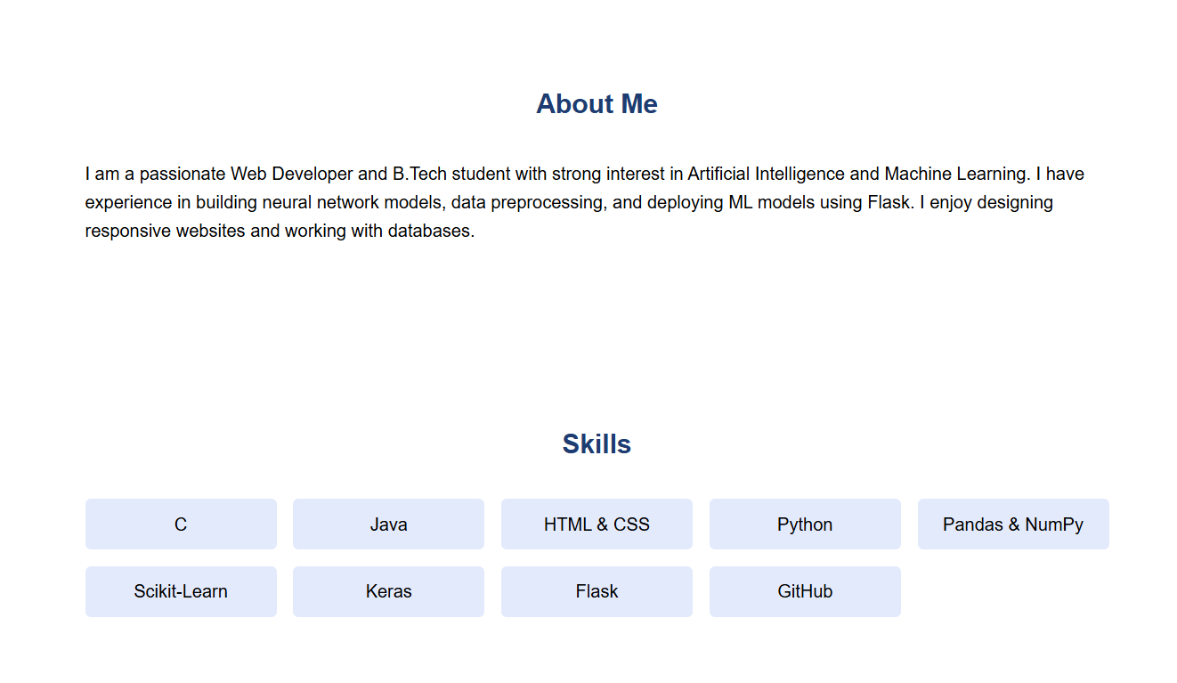
Projects:

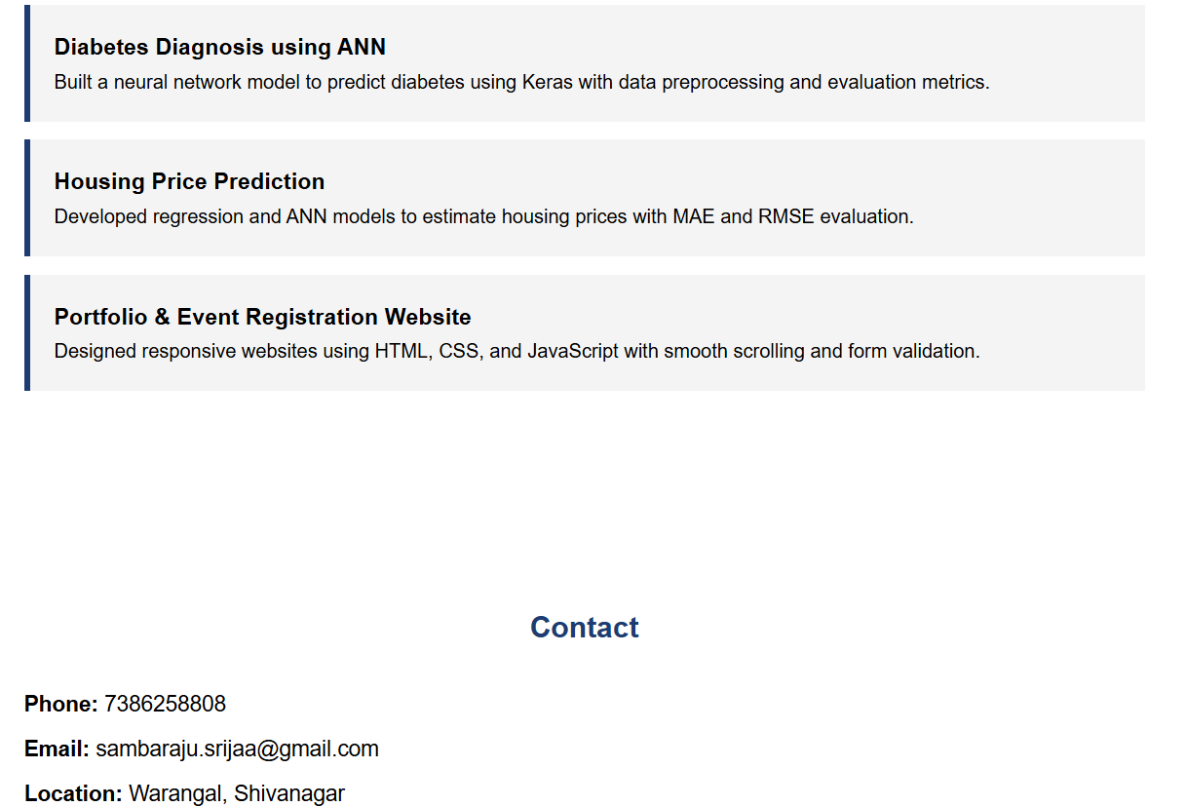

Observation:
The portfolio website was built using HTML, CSS, and JavaScript with a clean structure, including About, Projects, and Contact section navigation

Task2: Online Store Product Page

Prompt:

Design responsive product page with HTML, CSS (BEM), and JavaScript showing product details and an “Add to Cart” alert.

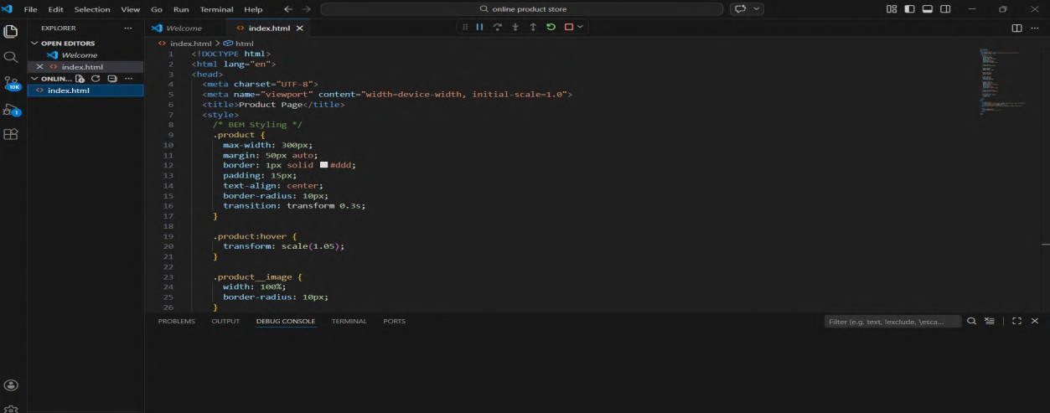
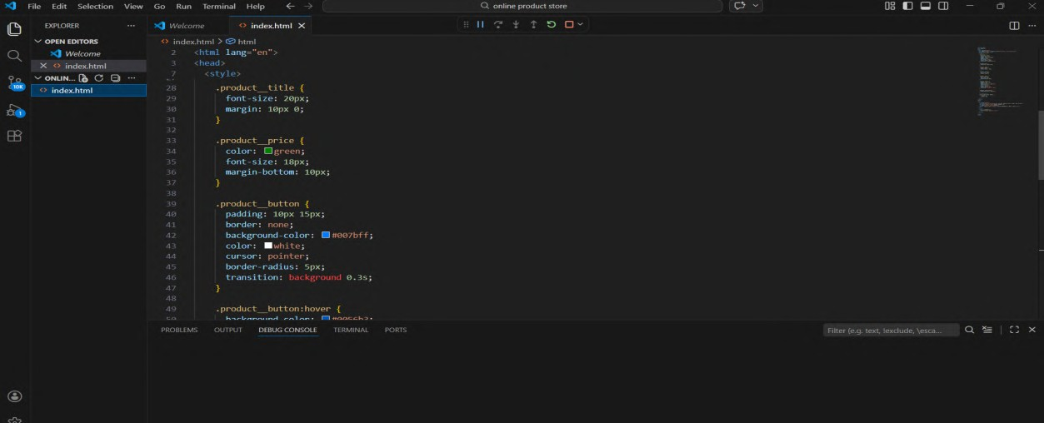
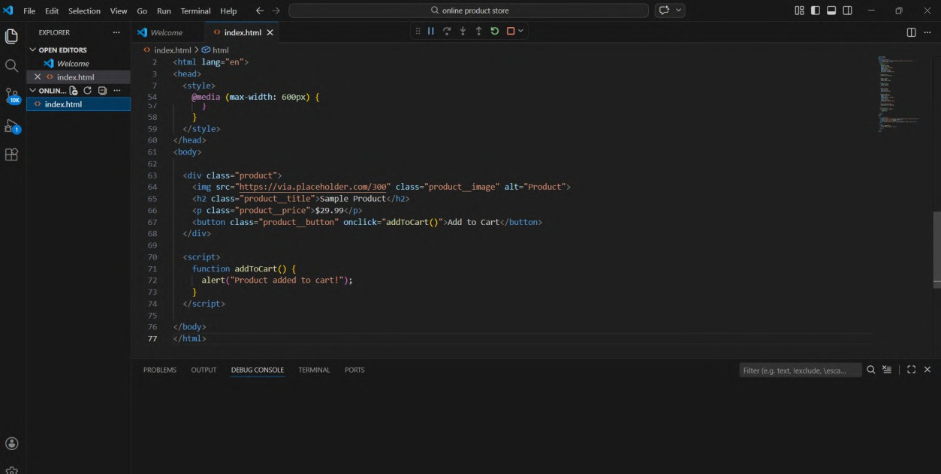

Output:
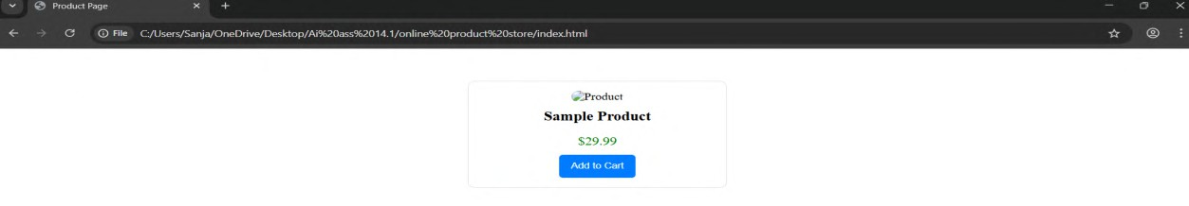

Observation:The product page is built using HTML, CSS, and JavaScript with a clean, structured, and responsive layout, using BEM for organized and reusable stylin

Task3: Event Registration Form
Prompt:
Create a styled, accessible event registration form with HTML, CSS, and JavaScript including validation for required fields before
submission.

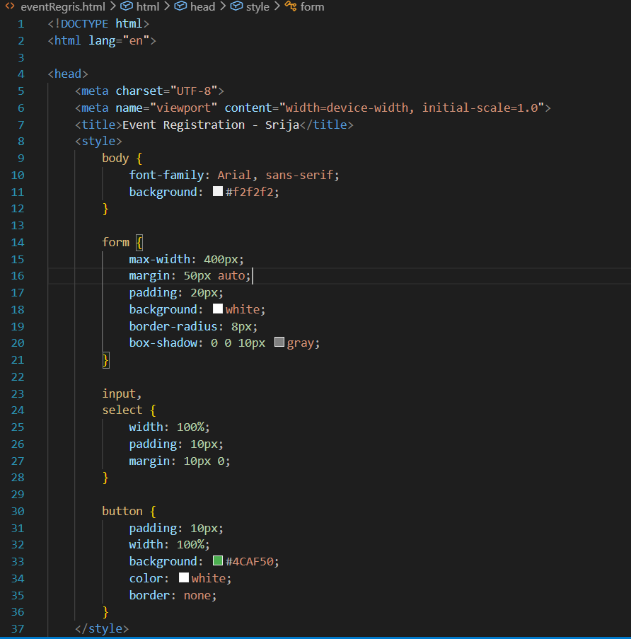

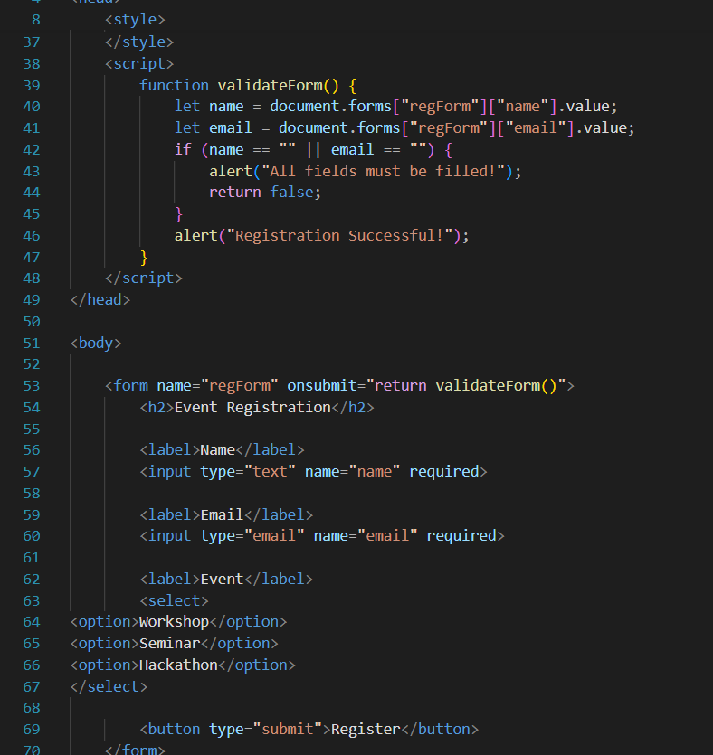
Output:

Observation:
The event registration form is developed using HTML, CSS, and JavaScript with a clean, responsive, and professional design.
Validation ensures accurate input, while labels and ARIA attributes improve accessibility and user experience.

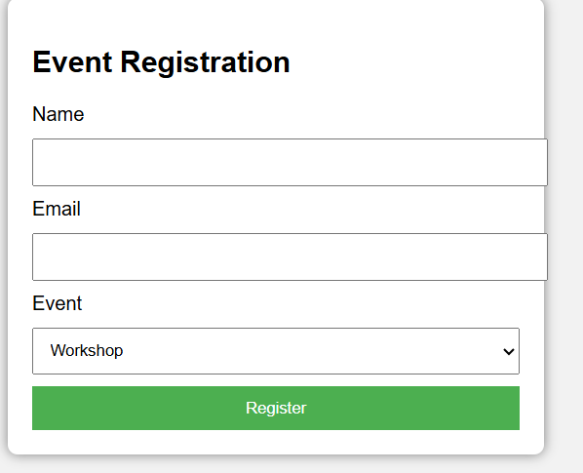

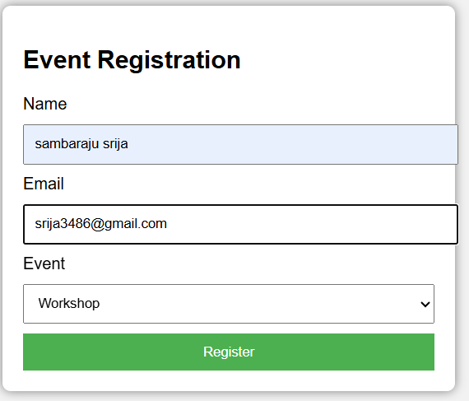

Task4: Resume Website Prompt:
Create a one-page resume website using HTML, CSS, and JavaScript with CSS Grid, smooth scrolling, and sections for Profile, Skills, Education, and Experience.
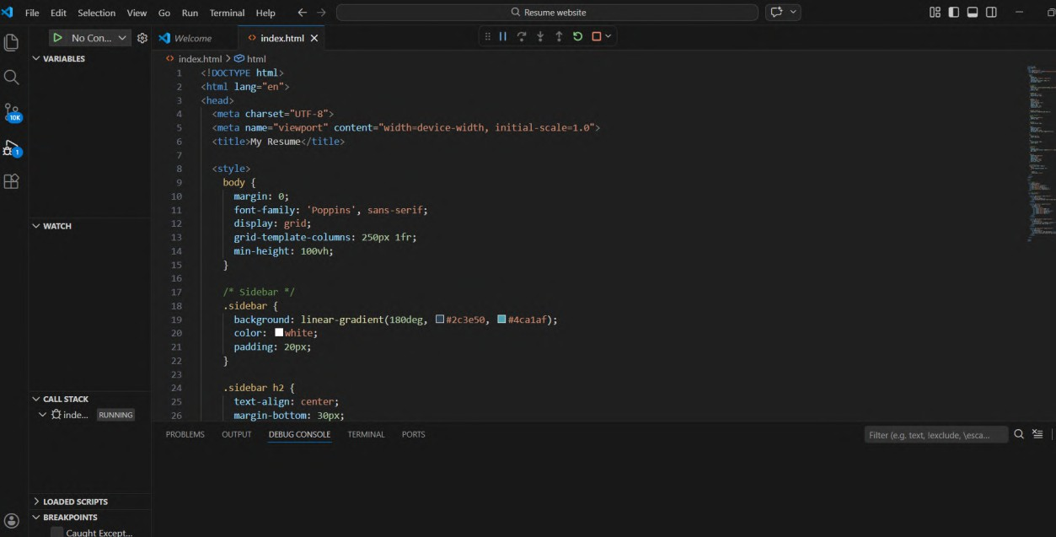
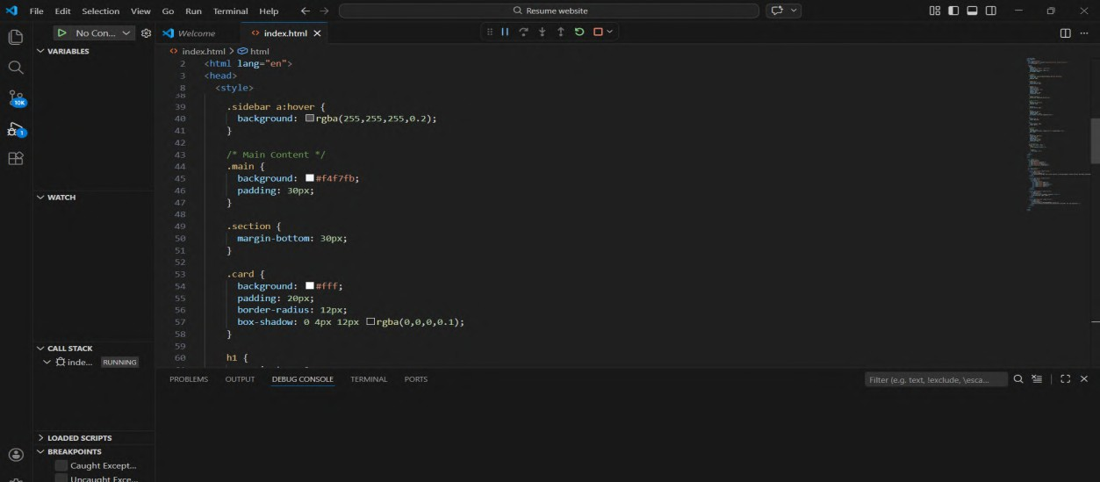

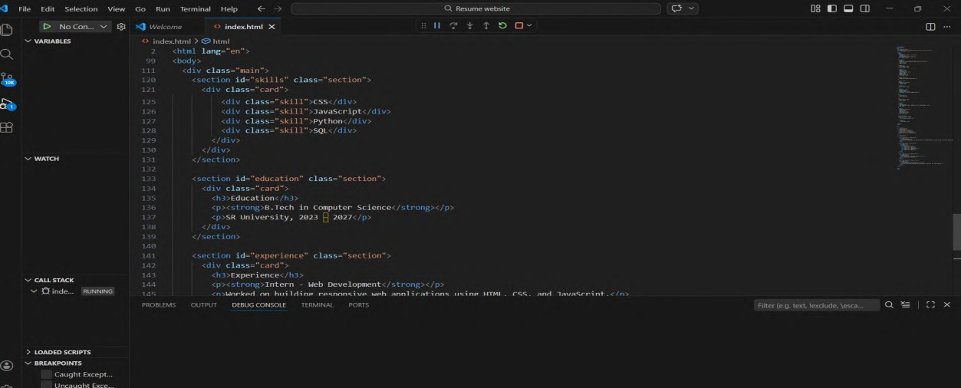

Output:
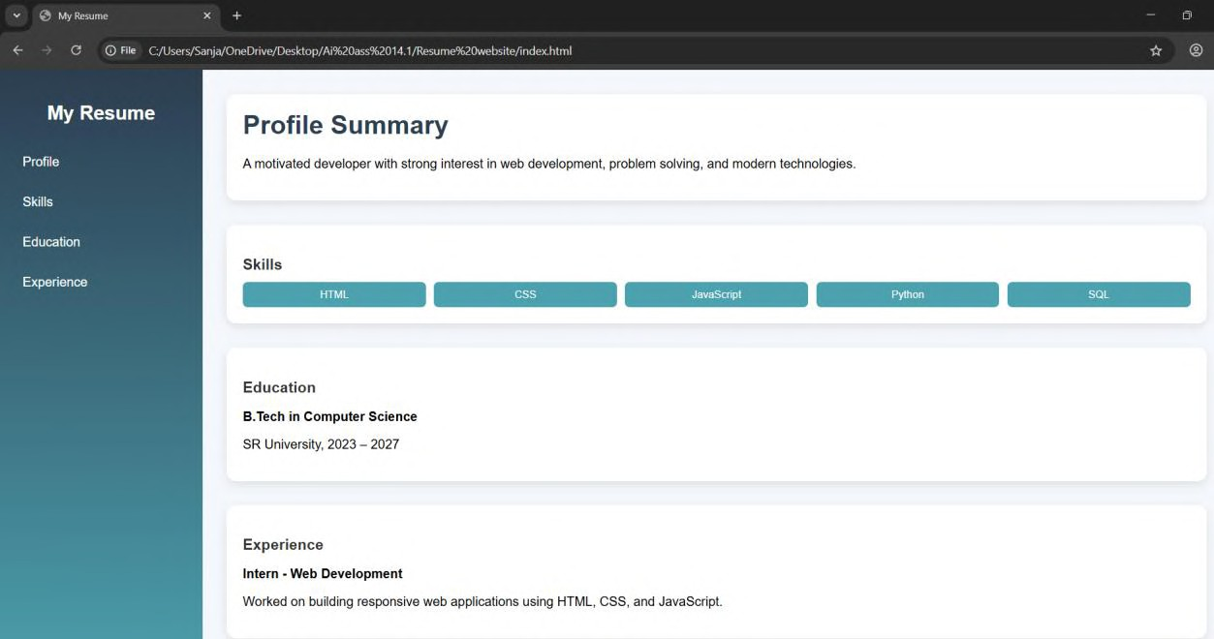

Observation:
The resume website uses a clean one-page layout with well- structured sections and professional typography.
CSS Grid and smooth scrolling enhance responsiveness, alignment, and overall user experience.

Task5: Restaurant Menu Page

Prompt:
Design a responsive restaurant menu page using HTML and CSS with a card layout, warm color palette, and hover effects displaying food details.
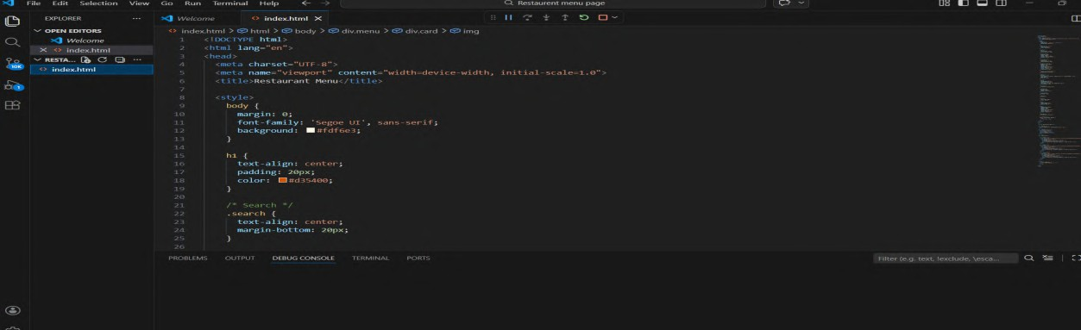
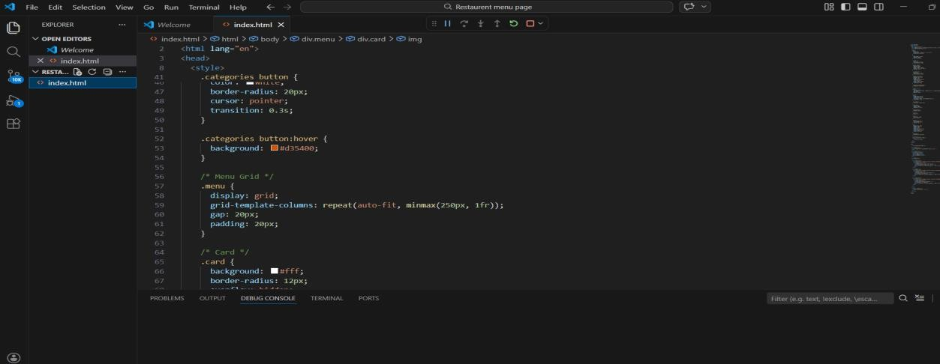
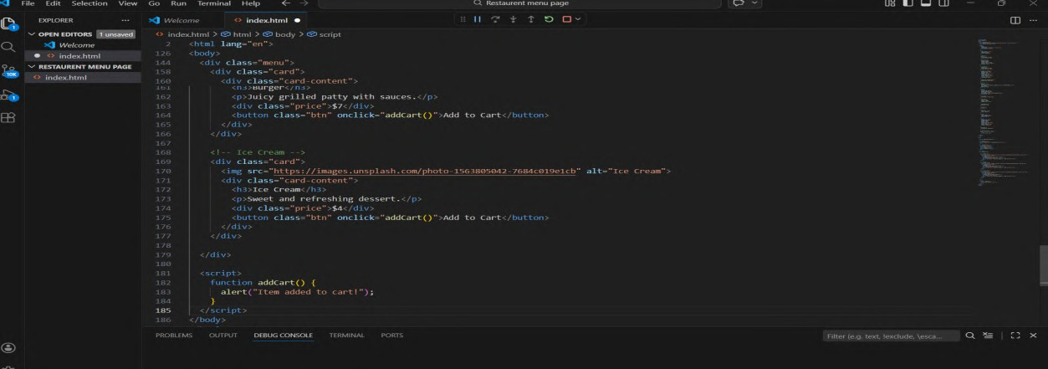

Output:
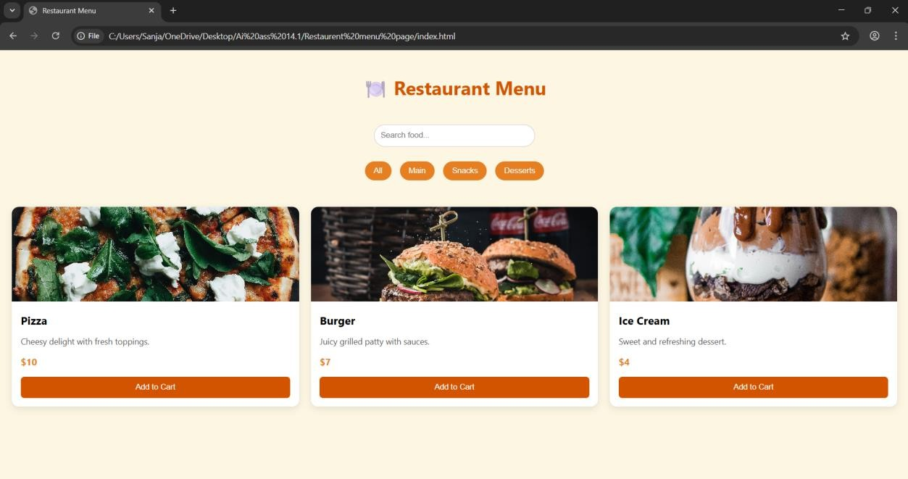
Observation:
The menu page uses a clean card-based layout with warm colors that enhance food appeal.
Responsive design and hover effects improve user interaction and browsing experience.

